Home TOC Prev. Next

Planetary strength: Shad bala
We know that a Graha may be well placed in the chart which would enable it to bring out it's most desirable qualities. Or the Graha may be afflicted in the chart, which would bring out it's most challenging side. But to what extent, and how strong will it act in life? How prominent will the Graha act in comparison to others? For this question, Jyotish has a very elaborate strength calculation. It is made up of 6 distinct components, each expressing the strength based on a unique dimension of the Grahas' placement. The total sum of these 6 strengths is called Shad Bala. Shad means six in Sanskrit, and Bala means strength. A complete overview of this is given in the Shad Bala report.
A Graha that ranks high in Shad Bala, is going to fully manifest its significations. It will be more prominent than other, weaker Grahas in the chart. Strong Grahas will strengthen the houses they rule, and will hold up the areas of life they represent well. A malefic Graha that is very strong, will be able to do more harm. A benefic Graha that is very strong will be able to bring a lot of good.
A Graha that ranks low in Shad Bala, will not manifest the area of life it represents. Those matters may remain wishes or dreams or thoughts, but never make it into full manifestation. The weaker the Graha, the more inhibited it's expression will be.
If a Graha is malefic and afflicted, it is actually good to be weak, since it will not be able to manifest harmful results. If the Graha is benefic and unafflicted but weak, the person will miss out on experiencing the full benefits of it's potential.
The six sources of strength are shown in the following table:
Source | Sthana bala (Positional strength) | Dig bala (Directional strength) | Kala bala (Temporal strength) | Chesta bala (Motional strength) | Naisargika bala (Natural strength) | Drik bala (Aspectual strength)
Basis | Sign positions | direction in the chart | time and date of birth | The velocity/ motion | fixed | Aspects from other planets
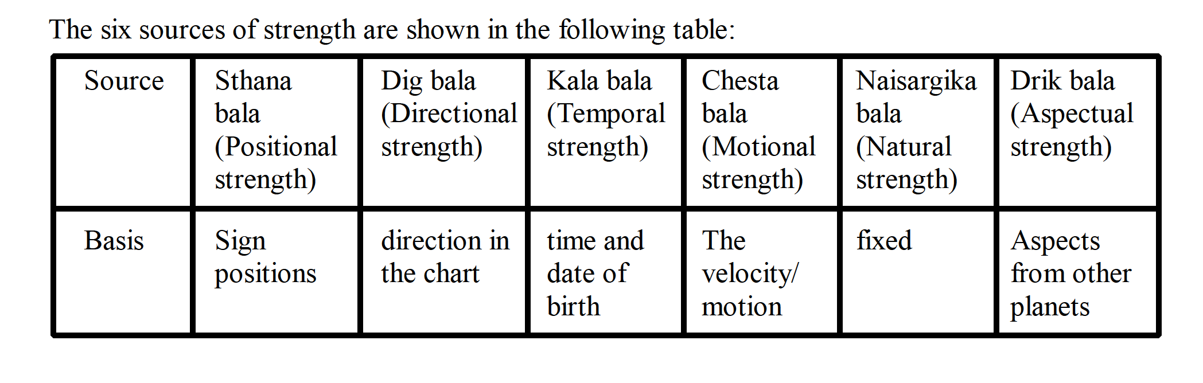
Sthana Bala
Dig bala
Kaala Bala
Ayana bala
Naisargika Bala
Drik bala
Chesta bala
Planetary war
Criteria for strength
Interpretation of Shad Bala
Shad bala summary for Surya
Shad bala summary for Chandra Shad bala summary for Mangal Shad bala summary for Budha
Shad bala summary for Guru Shad bala summary for Shukra
Shad bala summary for Shani

